

**A**

**PROJECT REPORT**

**On**

**“HelHub”**

**Submitted By**

**Janhvi Pali(233207)**

**Under the guidance of**

**Prof. Prashant Kori**

**SUBMITTED TO**



**Savitribai Phule Pune University**

**As a partial fulfilment for the award of the degree of**

**MASTER OF COMPUTER APPLICATIONS**

**At**

**ASM’S Institute of Business Management and Research,**

**MCA Institute, Chinchwad, Pune- 411019**

**A.Y 2024-202**

**Ref. No. ASM/IBMR/MCA Date:**

**CERTIFICATE**

***This is to certify that Mr. /Miss ___________________________________***

***is a bonafide student of _______________________________________ Programme of this institute for the academic year 2024 - 2025 .***

***He/ she has undertaken and completed the project work as prescribed by the Savitribai Phule Pune University for the partial fulfillment of MCA Programme on the topic _________________________________________ _____________________________________________________________***

***At: __________________________________________________________***

________________

**Internal Guide Dr. V. P. Pawar, Director**

**ASM’s IBMR, MCA Institute.**

## 

## ___________________

## **External Examiner**

**Ref. No. ASM/IBMR/MCA**

**TO WHOM SO EVER IT MAY CONCERN**

**This is to certify that Mr./Miss ____________________________, M.C.A. student from *ASM’s Institute of Business Management & Research, MCA Institute, Chinchwad*, has completed his project work titled:**

**“_______________________________________________________________________________________”**

**in our M.C.A. Department *from* *01/01/2024 to 30/04/2024* as a part of M.C.A. Semester-IV Curriculum.**

**We appreciate the efforts put in by the student while completing his project work during the above mentioned period.**

**_________________________________**

**Director**

**ASM’s IBMR, MCA Institute, Chinchwad**

ACKNOWLEDGEMENT

It is a pleasure to acknowledge the assistance of several people and institutions in this effort. This project has turned me into a debtor. First and foremost, I feel indebted to my guide ***Prof. Prashant Kori*** and all the faculty members of Department of MCA, ASM’s IBMR, MCA Institute Chinchwad for their valuable guidance, continuous support and advice and constant encouragement throughout my project work.

I would like to extend my gratitude to honorable **Dr. V. P. Pawar Sir, Director, ASM’s IBMR, MCA Institute, Chinchwad** for being a constant source of inspiration.

Finally, I would like to extend my thanks to all those who have contributed, directly or indirectly to make this project successful.

**Janhvi Pali (233207)**

**Index**

|  |  |  |  |
| --- | --- | --- | --- |
| **Chapter** | **Topic** | **Page No.** | |
| **1** | **INTRODUCTION** |  | |
| 1.1 | Company Profile/ Institute Profile ***<2pages>*** | 2 | |
| 1.2 | Abstract | 4 | |
| 1.3 | Existing System and Need for System <***1 + 1 pages>*** | 5 | |
| 1.4 | Scope of System | 7 | |
| 1.5 | Operating Environment- Hardware and Software | 8 | |
| 1.6 | Brief Description of Technology Used ***<At least 4 pages>*** | 9 | |
| **2** | **PROPOSED SYSTEM** |  | |
| 2.1 | Study of Similar Systems (Literature Survey) | 14 | |
| 2.2 | Feasibility Study ***<1 page>*** |  | |
| 2.3 | Objectives of Proposed System ***<1 page>*** |  | |
| 2.5 | User Requirements ***<1 page>*** |  | |
| **3** | **ANALYSIS & DESIGN** |  | |
| 3.1 | System Requirements (Functional and Non-Functional Survey) |  | |
| 3.2 | Data Flow Diagrams (DFD) |  | |
| 3.3 | Entity Relationship Diagram (ERD) |  | |
| 3.4 | Table Structure |  | |
| 3.5 | Use Case Diagrams |  | |
| 3.6 | Class Diagram |  | |
| 3.7 | Activity Diagram |  | |
| 3.8 | Sequence Diagram |  | |
| 3.9 | Deployment Diagram ***<Optional>*** |  | |
| 3.10 | Component Diagram ***<Optional>*** |  | |
| 3.11 | User Interface Designs ***<Screens must have valid Input data>*** |  | |
| 3.12 | Report <You must have at least 5 Reports with at least 5 valid records (Output).> |  |
| 4 | CODING |  |
| 4.1 | Algorithms |  |
| 4.2 | Code Snippet (Sample Code) |  |
| 5 | TESTING |  |
| 5.1 | Test Strategy |  |
| 5.2 | Test Case / Test Script |  |
| 5.3 | Defect Report / Test Log <Optional> |  |
| 6 | LIMITATIONS OF PROPOSED SYSTEM |  |
| 7 | PROPOSED ENHANCEMENTS |  |
| 8 | CONCLUSION |  |
| 9 | BIBLIOGRAPHY |  |
| 10 | USER MANUAL <Optional> <All screens with proper description> |  |

**CHAPTER 1**  **INTRODUCTION**



**Institute Profile**

**ASM's IBMR Pune - Institute of Business Management and Research**

**About ASM Group**

Established in 1983, the Audyogik Shikshan Mandal (ASM) Group of Institutes has completed 40 years in the field of education. Through this period, ASM has persistently provided the corporate world with well-prepared professionals. This history of excellence has been validated by the fact that ASM has consistently been ranked amongst the top B-Schools in India. The faculty of ASM comprises of the best in industry and academia The faculty members for the course are a rich blend of academicians, industry practitioners teaching faculty and mentors from industry. ASM has excellent industry-institute interaction for more than 4 decades and tie-ups with leading organizations for cutting edge certifications for enhanced skills leading to employability. ASM boasts of a strong alumni base of 72000+ graduates in leading corporates, who are very closely associated with the institute for placements & industry interfacing. Our objective is to offer the best of technological advancements to our students to make them the most sought after in the industry. Various tie-ups with Oracle, IBM etc. help us offer the best. The recent collaboration with IBM enables us to provide our students with certificate programs in Business analytics & Big Data from IBM to enable them to be ready for the most sought-after career in the recent times.

**Vision**

To be a world center of learning that excels in Management and IT education, research, training and consultancy.

**Mission**

Our mission is to attain excellence in education so as to contribute to the socio-economic transitions in the nation at all levels by presenting unique pedagogical opportunities aimed at developing effective, committed and dedicated, socially responsible global managers & leaders who make valuable contributions to all levels of the corporate world & society**.**

**Extra-Curricular Activities**

Opportunities for learning, growing and achieving exist everywhere at ASM’s IBMR. Life at IBMR is a blend of academics, extracurricular and co-curricular activities. Strong student clubs and cell activities give students opportunity to pursue hobbies of their interest. In addition, activities such as cultural programs, student fests, festival, national celebrations and intercollege events make life at IBMR truly colorful, enriching and enjoyable.

A year-round celebration of life is what it is all about at the Audyogik Shikshan Mandal Group of Institutes. Every year over 40 events are held across the various campuses. In the preceding year an overwhelming 60 events were held, making that an average of more than one per week.

Our students actively participate in various academic, co-curricular, extra-curricular, industry based, cultural and sports related competitions organized not only on campus but also at inter-college level. The students have consistently been top performers at such events, which only goes on to highlight the accent that ASM as an institute lays on all round growth of an individual. Sports, trekking, outdoor and fun activities not only act as welcome diversion from the rigors of theoretical class room sessions but also aims to unearth the latent talents and skills of our students which in turn help in the overall development of student’s personality.

**Website:** [**https://www.asmibmr.edu.in/**](https://www.asmibmr.edu.in/)

**Address:** ASM Group of Institutes, MIDC, Block ‘C’, Chinchwad, Pune, Maharashtra 411019

**Contact Number:** +91 9422009207/09/10/12

**Social Media Link**:

**LinkedIn**: <https://www.linkedin.com/in/asmgroup/>

**Facebook:** [**https://www.facebook.com/asmibmr/?ref=br_rs**](https://www.facebook.com/asmibmr/?ref=br_rs)

**Instagram:** [**https://www.instagram.com/asmgroupofinstitutes/**](https://www.instagram.com/asmgroupofinstitutes/)

--------------------------------------------------------------------------------------

**Abstract**

**HealHub** is a comprehensive digital healthcare platform designed to enhance medical accessibility, efficiency, and patient engagement through technology-driven solutions. It aims to bridge the gap between patients, doctors, and healthcare providers by integrating features such as telemedicine, AI-assisted diagnostics, and secure electronic health record (EHR) management. The platform empowers users to consult doctors remotely via video, audio, or chat, while also offering AI-powered symptom checkers for preliminary health guidance and medication reminders to support preventive care. Integration with wearable devices enables real-time health monitoring, further promoting wellness and chronic disease management.

HealHub comprises multiple core modules that cater to various stakeholders in the healthcare ecosystem. The **Admin Module** ensures access control and oversees system operations through employee management, system monitoring, and reporting features. The **Employee Management Module** handles authentication, payroll, and performance tracking for different roles such as pharmacists and cashiers. The **Customer Management Module** facilitates user registration, maintains purchase history, and supports loyalty programs and health notifications. Meanwhile, the **Sales and Purchase Management Modules** manage end-to-end sales transactions, stock updates, and procurement processes, ensuring inventory is accurate and medicines are up-to-date. The **Medicine Management Module** monitors stock levels, categorizes inventory, manages pricing, and sends alerts for low or expired stock. The **Supplier Management Module** handles supplier records, tracks order fulfillment, and facilitates communication with vendors.

Technically, the platform is built to run on Android devices with at least 2 GB RAM and 8 GB storage, using Java for the frontend and SQLite for the backend. It leverages Android SDK, Material Design Components, and various support libraries to deliver a seamless and responsive user experience. The system ensures high availability, robust performance under heavy load, and strong security measures to protect user data. Designed with scalability in mind, HealHub is also positioned for future enhancements such as predictive analytics using AI, blockchain-secured health data, virtual reality therapies, and advanced IoT-based patient monitoring. Ultimately, HealHub aspires to become a one-stop solution for accessible, intelligent, and secure healthcare delivery.

**1.3** **Existing System and Need for System  
  
Existing System:**

In the existing healthcare management landscape, many clinics, pharmacies, and healthcare providers rely on manual or semi-automated processes to manage patient data, appointments, medicine inventory, and communication. These conventional systems often consist of disjointed tools for booking, billing, record-keeping, and stock tracking, which leads to inefficiencies and fragmented workflows. Patient records are frequently stored in physical files or basic spreadsheet-based systems, making data retrieval time-consuming and prone to errors. Appointment scheduling is typically handled through manual logs or basic calendar apps, requiring staff intervention and offering no real-time availability tracking. There is limited integration with modern technologies like AI for symptom checking or wearable devices for remote monitoring. Additionally, managing medicine inventories and purchase records is usually a manual task, lacking automated stock alerts or expiration tracking, which increases the risk of human error. Communication between patients and healthcare providers is also inefficient, often limited to phone calls or SMS, without a secure or centralized platform. Overall, the absence of a unified, intelligent, and secure system hampers productivity, delays medical response times, and compromises the overall quality of healthcare services.

**Need for System:**

* **Improves healthcare accessibility** for users in remote or rural areas through teleconsultation features.
* **Reduces waiting time** by enabling easy online appointment booking, rescheduling, and cancellation.
* **Sends medication and health reminders** to promote better treatment adherence and preventive care.
* **Provides secure digital health records (EHR)**, eliminating the risks of losing or damaging paper-based documents.
* **Enables real-time consultations** via video, audio, and chat with verified medical professionals.
* **Supports emergency situations** by giving quick access to hospitals, pharmacies, and emergency contacts.
* **Assists chronic disease management** (e.g., diabetes, hypertension) through monitoring tools and consistent follow-up.
* **Encourages continuous patient-doctor engagement** through reminders, virtual visits, and record sharing.
* **Leverages AI technology** to offer smart symptom checking and predictive health insights.
* **Integrates with wearable devices** (e.g., smartwatches, fitness trackers) for real-time health data collection.
* **Enhances patient experience** with a user-friendly interface and secure access to all healthcare tools in one app.
* **Fulfills modern healthcare expectations** in a fast-paced, digital-first world.

**1.4 Scope of System**

The HealHub project aims to develop a comprehensive digital healthcare platform that serves the needs of patients, doctors, and healthcare providers through a unified mobile application. The platform will enable patients to easily book, reschedule, and cancel doctor appointments, securely store and access their medical records, receive medication reminders, and consult doctors remotely via video, audio, or chat. Additionally, users will benefit from AI-powered symptom checkers for preliminary health guidance and emergency assistance features for quick access to hospitals and pharmacies.

For doctors and healthcare providers, HealHub offers a powerful backend to manage appointments, conduct virtual consultations, issue e-prescriptions, and maintain digital medical histories of patients. The system also includes modules for managing medicine inventory, tracking sales and purchases, monitoring employee performance, and maintaining supplier relations. It supports real-time health monitoring by integrating with wearable devices and provides detailed reports and analytics for better decision-making.

The platform will be built for Android devices using Java, SQLite, and Android SDK, ensuring compatibility with widely used mobile hardware. Security, usability, scalability, and performance are core considerations, making HealHub a reliable and future-ready healthcare solution. The scope also includes potential future enhancements such as predictive healthcare through AI, blockchain-based health records, and remote monitoring using IoT, making it scalable for long-term growth and adoption.

**1.5 Operating Environment - Hardware and Software**

|  |  |
| --- | --- |
| **HARDWARE SPECIFICATION** | |
| Operating System | Windows 10 and above / Ubuntu 20.04+ |
| Processor | Intel(R) Core (TM) i5-10210U CPU 2.11 GHz or higher |
| RAM | 8 GB |
| Hard Disk | 1 TB |
|  | |
| **SOFTWARE SPEIFICATION** | |
| **Component** | **Technology Used** |
| **Data Storage** | Snowflake Cloud Data Warehouse |
| Containerization | Docker |
| **Backend** | Django, Python |
| Frontend | React JS, HTML, CSS |
| Scheduling & Execution | Custom Scheduler via Django Admin + Cron Jobs |
| **APIs** | Snowflake Connector, Custom REST APIs |

**1.6 Brief Description of Technology Used**

The **HealHub** system is developed using a combination of frontend and backend technologies that together deliver a robust, interactive, and secure healthcare platform.

* **Java:**  
  Java is used primarily for developing the Android mobile application. It powers the frontend logic on mobile devices, enabling users to interact with features like appointment booking, symptom checking, and accessing medical records through a responsive and intuitive interface.
* **PHP:**  
  PHP is used to develop the server-side backend of the application. It handles core functionalities such as processing requests from the app, managing sessions, interacting with the database, and executing business logic securely and efficiently.
* **HTML (and CSS/JavaScript):**  
  HTML is used to build the web-based admin dashboard and interfaces for browser access. Along with CSS and JavaScript, it ensures a clean and user-friendly experience for administrators managing data, appointments, and analytics.
* **MySQL:**  
  MySQL serves as the relational database management system for storing structured data such as patient records, doctor profiles, appointments, prescriptions, sales history, and inventory information. It is chosen for its reliability, scalability, and compatibility with PHP.

**CHAPTER 2**

**PROPOSED SYSTEM**

**2.1 Study of Similar Systems**

|  |  |  |  |
| --- | --- | --- | --- |
| **Sr.No** | **App Name** | **Description** | **Remark** |
| 1. | * Practo | * Online doctor consultation, appointment booking, and medicine delivery. | * Lacks AI-based symptom checking and predictive healthcare insights. |
| 2. | * Mfine | * AI-powered telemedicine platform for virtual doctor consultations.. | * Strong AI integration but limited in EHR (Electronic Health Records) management |

**2.2 Feasibility Study**

The system leverages mature and well-supported technologies such as Java, PHP, HTML, and MySQL, which are widely documented and used in production-grade applications.  
➤ The development team has the necessary skills in Java (for Android), PHP (for backend), MySQL (for database management), and web technologies like HTML, CSS, and JavaScript.  
➤ The use of MySQL ensures secure, reliable, and scalable data storage for managing structured healthcare data including patient records, prescriptions, and inventory.  
➤ Android SDK and Java offer strong compatibility across a wide range of devices, allowing for broad user accessibility.  
➤ The tech stack supports integration with APIs, wearable devices, and future AI modules (e.g., symptom checkers), enhancing system capabilities.  
➤ The system architecture is modular and extensible, making it easy to incorporate future features like blockchain security, predictive analytics, or advanced reporting tools.

### ****2.Operational Feasibility****

The HealHub project is economically viable, with cost-effective development tools and a high return on investment through improved healthcare service delivery.  
➤ The technology stack (Java, PHP, HTML, MySQL) is open-source and free to use, minimizing software licensing costs.  
➤ Development can be carried out with readily available resources, reducing the need for expensive specialized personnel.  
➤ The platform will automate manual healthcare operations, significantly reducing administrative overhead and labor costs.  
➤ Long-term cost savings will be achieved by reducing paper records, in-person visits, and inefficiencies in appointment handling and inventory management.  
➤ Revenue opportunities can be created through subscription models, premium features, partnerships with clinics, or pharmacy integrations..

### ****4. Legal Feasibility****

The HealHub system complies with relevant laws and regulations concerning digital healthcare, patient data, and software deployment.  
➤ The system is designed to align with international data protection laws such as **HIPAA (Health Insurance Portability and Accountability Act)** and **GDPR (General Data Protection Regulation)** to ensure the privacy and security of patient health data.  
➤ User data (e.g., medical records, prescriptions) is stored securely in encrypted form, and access is restricted through authenticated login and role-based permissions.  
➤ The platform adheres to local laws related to telemedicine, digital prescriptions, and online pharmacy services where applicable.  
➤ Clear terms of use and privacy policies will be incorporated to inform users about data usage, rights, and consent requirements.  
➤ Integration with third-party services and wearable devices will comply with legal standards for data sharing and interoperability.  
➤ Regular audits and compliance checks can be incorporated to ensure that all healthcare and software-related legal obligations are continuously met.

**2.3 Objectives of Proposed System**

**1. Technical Feasibility**

The HealHub project is technically sound and achievable using a proven, open-source, and developer-friendly technology stack.  
➤ The system is built using **Java** for Android development, **PHP** for backend processing, **HTML/CSS/JavaScript** for the web interface, and **MySQL** as the database.  
➤ These technologies are mature, widely documented, and have strong community and library support, reducing implementation risk.  
➤ The development team possesses the necessary skills and experience in mobile app development, web programming, database design, and system integration.  
➤ The chosen tools (Android Studio, XAMPP, MySQL Workbench, etc.) are freely available, lightweight, and suitable for rapid prototyping and full-scale deployment.  
➤ The system supports integration with third-party APIs and wearable devices, enabling features like real-time data capture and AI-based symptom analysis.  
➤ The modular system architecture makes it easy to add or upgrade features in the future without major system overhaul.  
➤ Security, scalability, and compatibility with Android devices are considered in the core design, ensuring reliable performance across different environments.

**2. Operational Feasibility**

The **HealHub** system is highly feasible from an operational standpoint and aligns well with the needs of healthcare professionals, patients, and administrative staff.  
The platform is designed with user-friendly interfaces that require minimal training, ensuring quick adoption by doctors, patients, and pharmacy staff.  
Patients can easily register, book appointments, access their medical records, and consult doctors remotely via video, audio, or chat.  
Healthcare providers can manage appointments, generate prescriptions, monitor patient history, and communicate effectively through a single integrated system.  
Administrative staff can efficiently handle inventory, employee roles, sales, and supplier management, which reduces workload and improves service delivery.  
Automated features such as reminders, low-stock alerts, and real-time data tracking significantly reduce the risk of human error and improve operational efficiency.  
The system can operate 24/7 with minimal maintenance, enabling continuous access to services and better support for emergency or time-sensitive medical needs.  
Regular usage of the system will improve healthcare record accuracy, speed up workflows, and contribute to better patient care and satisfaction.  
Overall, the system supports the real-world healthcare workflow and enhances productivity while providing a dependable and smooth user experience.

**3. Legal Feasibility**

* **Data privacy and security:**  
  Data in transit and at rest is encrypted using secure protocols (e.g., HTTPS and encryption at the database level) to protect user information from unauthorized access or breaches.
* **Sensitive personal data:**  
  The system does not store personally identifiable information (PII) unless explicitly required and adheres to established data protection policies, including HIPAA, GDPR, and local healthcare data laws.
* **API usage:**  
  Integration with third-party services (e.g., AndroidX libraries, Gradle, and healthcare tools) is conducted under proper licensing and in full compliance with their terms of service and usage limitations.
* **User consent and legal disclaimers:**  
  Explicit user consent is obtained before collecting or using any health-related information. Legal disclaimers clarify that AI-powered insights are not substitutes for professional medical advice.
* **Environment variable management:**  
  Secure handling of sensitive credentials (API keys, database passwords) is managed through environment variables to prevent exposure in source code or repositories.
* **E-prescriptions and telemedicine compliance:**  
  All virtual consultations and e-prescriptions are provided only by verified, licensed healthcare professionals in accordance with telemedicine and prescription laws.
* **Terms of service and privacy policy:**  
  The application includes a comprehensive Terms of Service and Privacy Policy outlining data usage, user rights, and limitations of liability.

**2.4 User Requirement**

The HealHub application is intended to serve multiple user groups including patients, doctors, administrators, and suppliers. The following user requirements ensure that each stakeholder can interact with the system efficiently and securely:

#### **1. Patient Requirements**

* Must be able to **register and log in** securely.
* Should be able to **book, reschedule, or cancel doctor appointments** via the app.
* Must have access to **electronic health records (EHRs)** including past prescriptions and reports.
* Should receive **personalized medication reminders and health alerts**.
* Must be able to **consult doctors via video, audio, or chat**.
* Should be able to use the **AI-powered symptom checker** for preliminary guidance.
* Must have access to **emergency contacts, hospitals, and pharmacies** through the app.
* Should be able to sync with **wearable health devices** for real-time monitoring.

#### **2. Doctor/Healthcare Provider Requirements**

* Must be able to **log in and manage their professional profile**.
* Should be able to **view and manage appointments** with patients.
* Must be able to **provide virtual consultations** through video, audio, or text.
* Should be able to **access and update patient medical histories**.
* Must be able to **generate and send e-prescriptions**.

#### **3. Admin Requirements**

* Must have **secure access to the admin dashboard**.
* Should be able to **manage employee accounts and roles** (e.g., pharmacists, cashiers).
* Must be able to **monitor system transactions**, including sales and purchases.
* Should be able to **generate audit and analytics reports**.

#### **4. Supplier Requirements**

* Should be able to **register and manage their profile**.
* Must be able to **receive and manage supply orders**.
* Should have access to **performance and delivery tracking**.

#### **5. General System Requirements for All Users**

* The system must allow new users to **create accounts with verification**.
* All users should have a **user-friendly interface** compatible with Android OS.
* The system must ensure **data privacy and secure access control**.
* The app should support **real-time notifications and alerts**.
* The system should allow users to **communicate with each other** where applicable (e.g., doctor-patient messaging).

**CHAPTER 3**

**ANALYSIS AND DESIGN**

**3.1 System Requirements (Functional and Non-Functional requirements)**

**1.1 Functional Requirements**

The functional requirements define the core functionalities that the HealHub system must provide to meet the needs of users including patients, doctors, administrators, and suppliers.

#### **1. User Authentication and Account Management**

* The system shall allow users (patients, doctors, admins, suppliers) to register and create accounts.
* The system shall require secure login credentials (username and password) for user access.
* The system shall validate and store user details securely in the database.
* The system shall provide password recovery and account update functionality.

#### **2. Appointment Booking and Management**

* Patients shall be able to book, reschedule, or cancel doctor appointments.
* Doctors shall be able to view and manage their scheduled appointments.
* The system shall send notifications/reminders for upcoming appointments.

#### **3. Telemedicine and Virtual Consultation**

* The system shall enable real-time audio, video, or chat-based consultations between patients and doctors.
* The system shall support secure communication channels during virtual consultations.
* The system shall store consultation history for future reference.

#### **4. AI Symptom Checker**

* The system shall allow users to input symptoms and receive AI-generated health insights.
* The AI engine shall analyze the inputs and provide basic recommendations (not diagnoses).
* The system shall display disclaimers regarding the non-substitutive nature of AI suggestions.

#### **5. Electronic Health Records (EHR) Management**

* Patients shall be able to upload, store, and view medical reports and history.
* Doctors shall have access to a patient's EHR during consultations.
* The system shall ensure encryption and privacy of all health records.

#### **6. Medication and Health Reminders**

* The system shall allow users to set personalized reminders for medication intake and health checkups.
* The system shall send timely alerts through push notifications or in-app messages.

#### **7. Emergency Services Access**

* The system shall provide users with quick access to nearby hospitals, emergency contacts, and pharmacies**.**

#### **8. Doctor and Admin Dashboard**

* Doctors shall manage appointments, e-prescriptions, and patient information from a dedicated dashboard.
* Admins shall manage user roles, monitor system activities, and generate business reports.

#### **9. Inventory and Medicine Management**

* The system shall track medicine stock, pricing, and categorization.
* Admins and staff shall receive alerts for low or expired stock.
* The system shall maintain purchase and sales records.

#### **10. Supplier and Purchase Management**

* Admins shall register and manage suppliers in the system.
* The system shall track medicine purchase orders and update stock upon delivery.
* The system shall maintain supplier performance logs.

### ****2. Non-Functional Requirements****

Non-functional requirements define the system's overall attributes, such as performance, usability, and security.

1. **Performance**  
   The system must be able to return query results within 5–10 seconds for real-time insights. It should be able to support multiple concurrent users querying the system without performance degradation.
2. **Scalability**  
   The platform must scale efficiently as data volume grows, able to handle increasing amounts of data, users, and queries without slowing down or causing interruptions in service.
3. **Usability**  
   The web interface should be highly intuitive, user-friendly, and designed for non-technical users. It should require no prior knowledge of SQL or technical expertise to operate and interact with the system.
4. **Reliability**  
   The system should ensure high availability and reliability, guaranteeing that users can access data and insights without downtime. The system should provide accurate, up-to-date data always.
5. **Security**
   * **Sensitive Data Protection:** The system should ensure that sensitive data, including credentials, is securely managed using environment variables (.env files) to store API keys and other sensitive information.
   * **Encryption:** All external communications, including data transfers, should be encrypted using HTTPS to ensure confidentiality and integrity.
   * **Access Control:** Role-based access control (RBAC) must be implemented to ensure that only authorized users can access sensitive data and perform administrative tasks.
6. **Portability**  
   The system should be accessible from a variety of devices, including desktops, laptops, and mobile devices. The web interface should be fully responsive, ensuring an optimal user experience across all screen sizes.

**3.2 Data Flow Diagram (DFD):**

**LEVEL 0:**

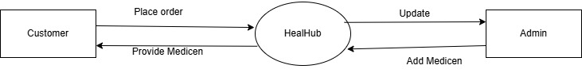

**LEVEL 1:**

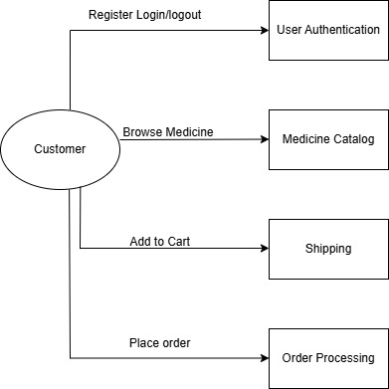

**LEVEL 2:**

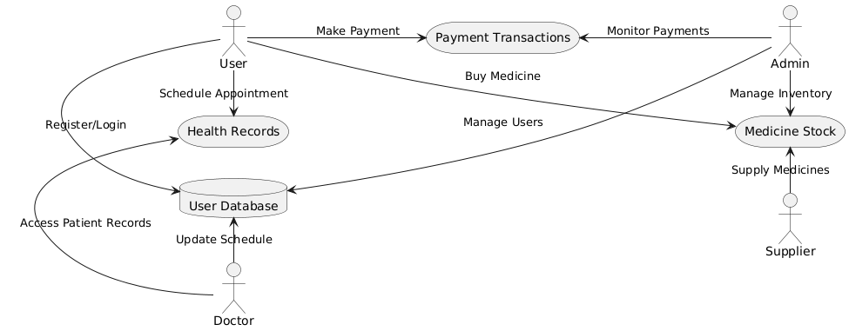

**3.3 Entity Relationship Diagram (ERD):**

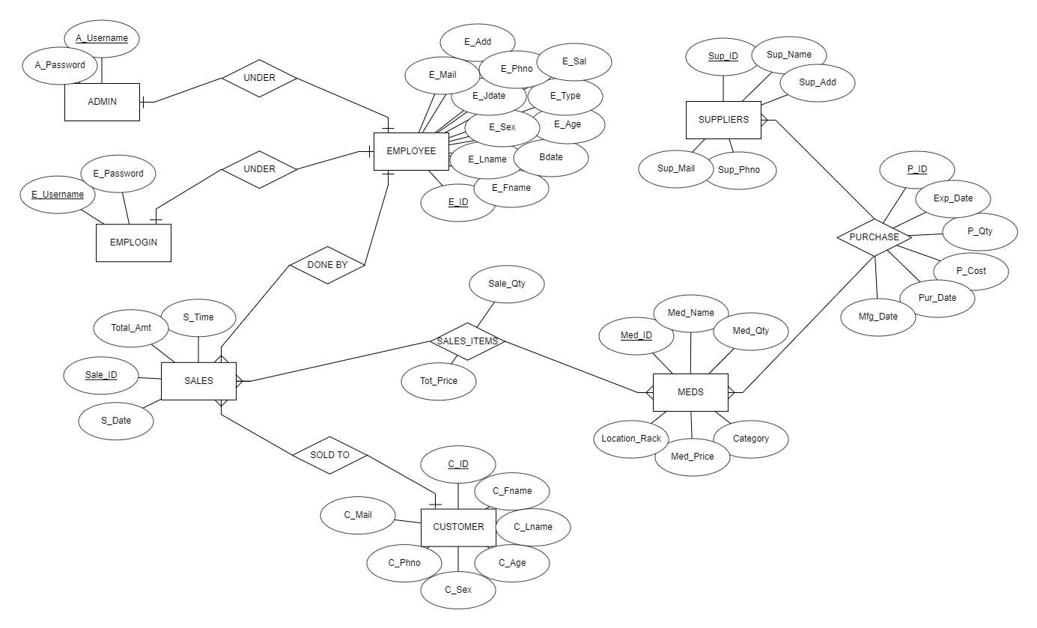

**3.4 Table Structure**

**1.USER**

|  |  |  |
| --- | --- | --- |
| **Column Name** | **Data Type** | **Constraint** |
| **u_id** | **INT** | **Primary Key (PK), Auto Increment** |
| **u_name** | **VARCHAR(100)** | **NOT NULL** |
| **email** | **VARCHAR(150)** | **UNIQUE, NOT NULL** |
| **contact** | **BIGINT** | **UNIQUE** |

**2.** **Appointments Table**

|  |  |  |
| --- | --- | --- |
| **Column Name** | **Data Type** | **Constraint** |
| **appointment_id** | **INT** | **Primary Key (PK), Auto Increment** |
| **user_id** | **INT** | **Foreign Key (FK) → Users(u_id)** |
| **doctor_id** | **INT** | **Foreign Key (FK) → Doctors(doctor_id)** |
| **appointment_date** | **DATETIME** | **NOT NULL** |
| **status** | **ENUM('Scheduled', 'Completed', 'Cancelled')** | **Default: Scheduled** |

**3.** **Payments Table**

|  |  |  |
| --- | --- | --- |
| **Column Name** | **Data Type** | **Constraint** |
| **payment_id** | **INT** | **Primary Key (PK), Auto Increment** |
| **user_id** | **INT** | **Foreign Key (FK) → Users(u_id)** |
| **amount** | **DECIMAL(10,2)** | **NOT NULL** |
| **payment_date** | **TIMESTAMP** | **Default: CURRENT_TIMESTAMP** |
| **status** | **ENUM('Pending', 'Completed', 'Failed')** | **Default: Pending** |

**4.** **Doctor Table**

|  |  |  |
| --- | --- | --- |
| **Column Name** | **Data Type** | **Constraint** |
| **doctor_id** | **INT** | **Primary Key (PK), Auto Increment** |
| **user_id** | **INT** | **Foreign Key (FK) → Users(u_id)** |
| **specialization** | **VARCHAR(100)** | **NOT NULL** |
| **experience** | **INT** | **NOT NULL** |

**5.** **Medicines Table**

|  |  |  |
| --- | --- | --- |
| **Column Name** | **Data Type** | **Constraint** |
| **medicine_id** | **INT** | **Primary Key (PK), Auto Increment** |
| **name** | **VARCHAR(100)** | **NOT NULL** |
| **stock** | **INT** | **Default: 0** |
| **price** | **DECIMAL(10,2)** | **NOT NULL** |

**6 Orders Table**

|  |  |  |
| --- | --- | --- |
| **Column Name** | **Data Type** | **Constraint** |
| **order_id** | **INT** | **Primary Key (PK), Auto Increment** |
| **Order_no** | **INT** | **Primary Key (PK), Auto Increment** |

**3.5 Use Case Diagrams**

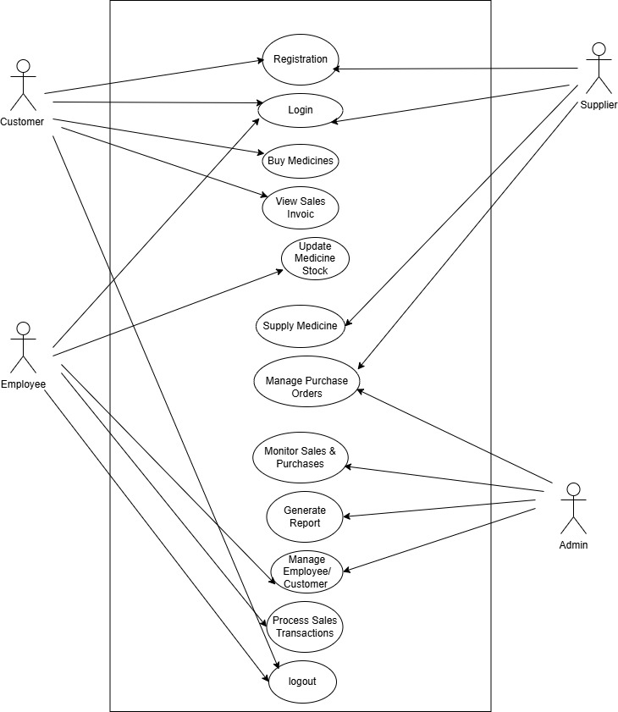

**3.6 Activity Diagram**

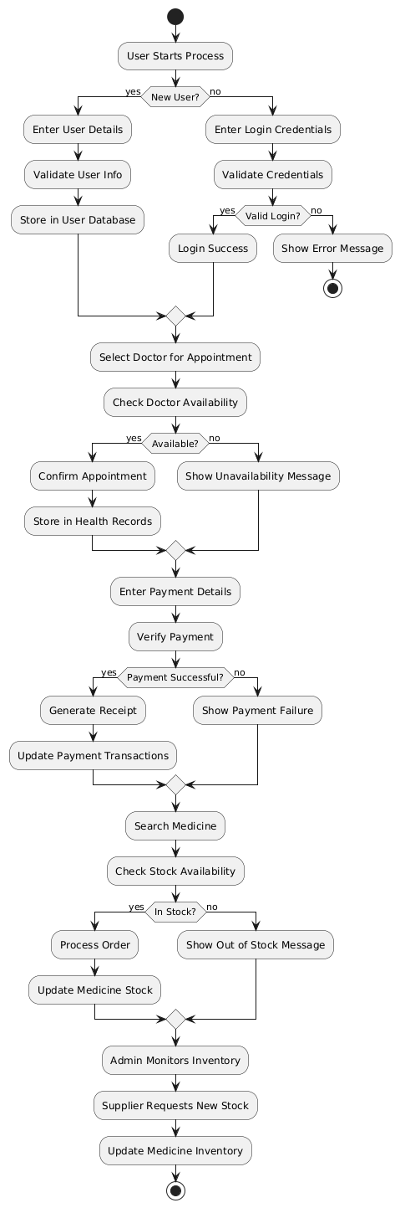

**3.7 Sequence Diagram**

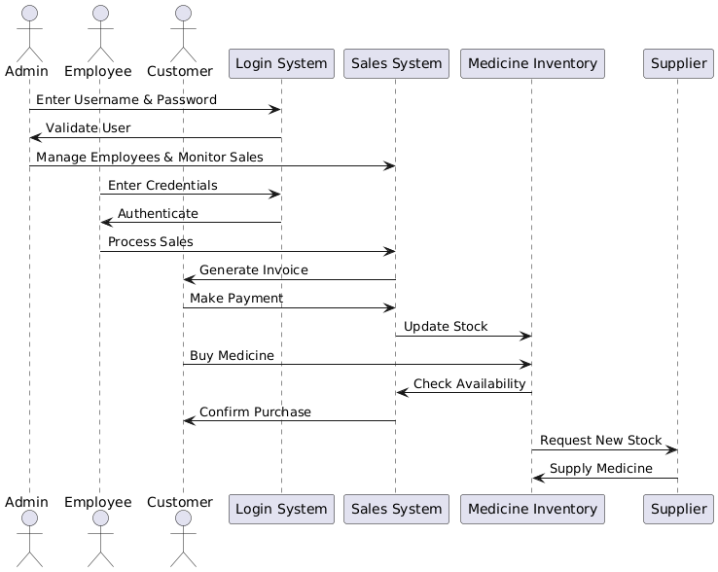

**3.8 Class Diagram**

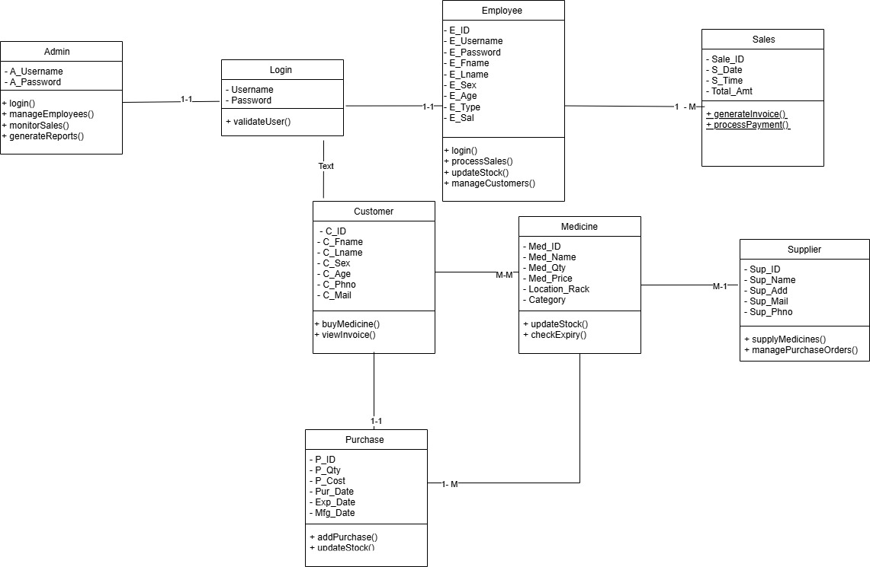

**3.9 User Interface Design**

Index

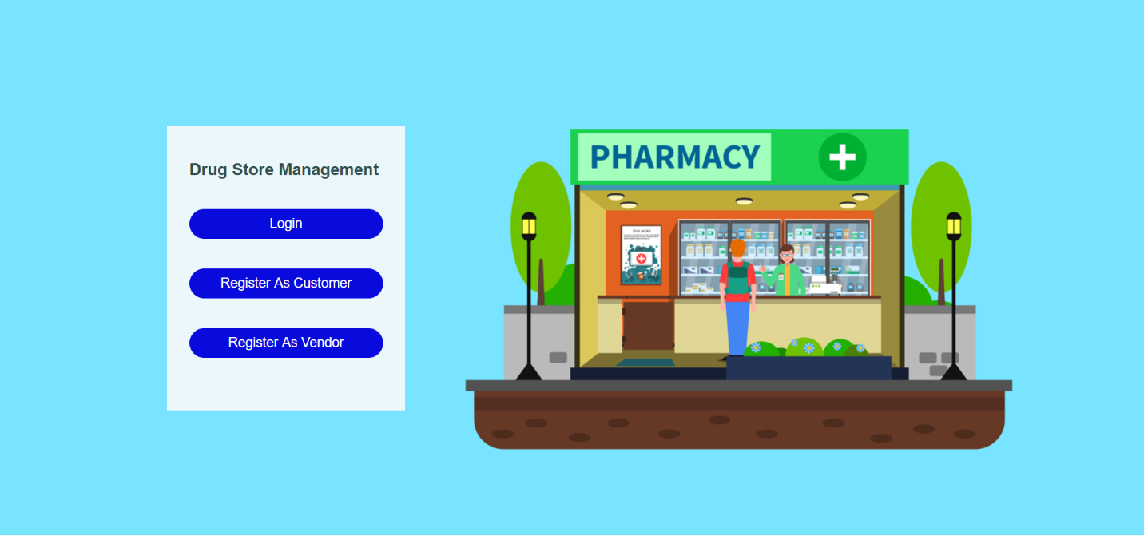

Registration

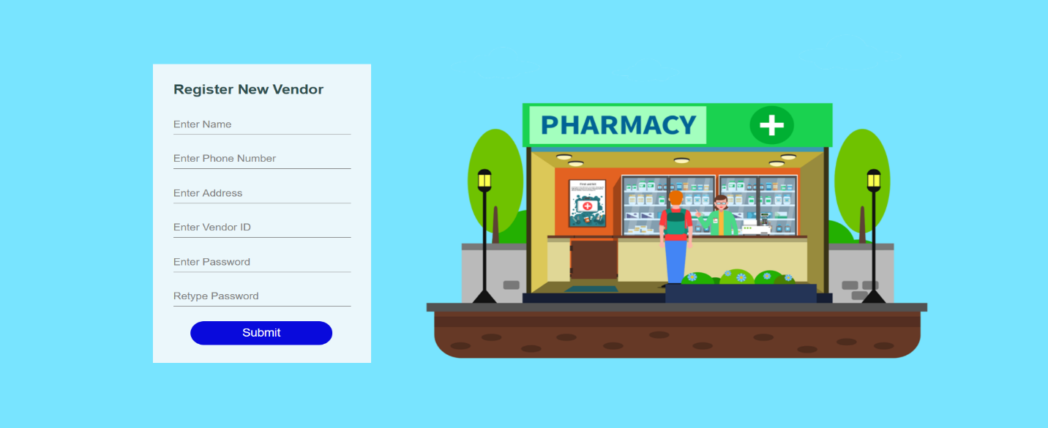

Login

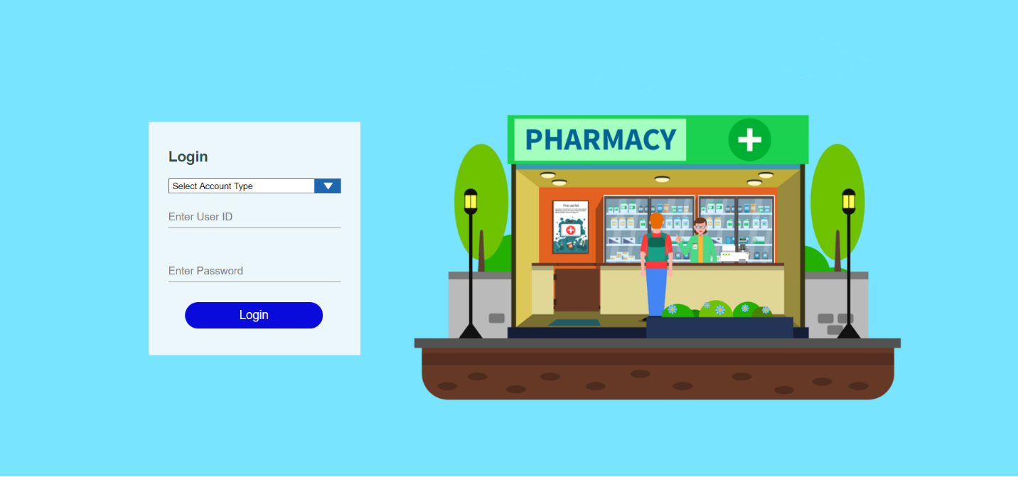

Vender home page

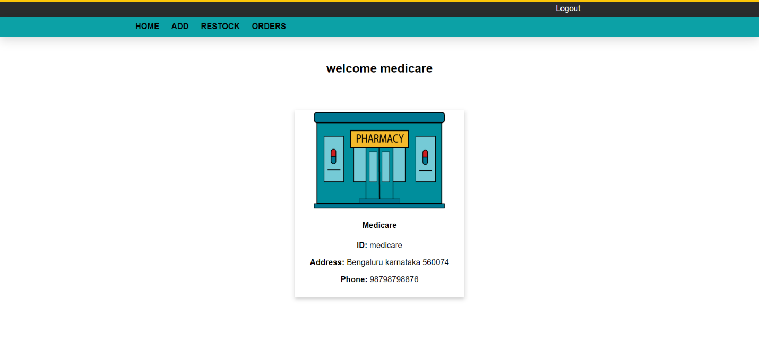

Customer home page

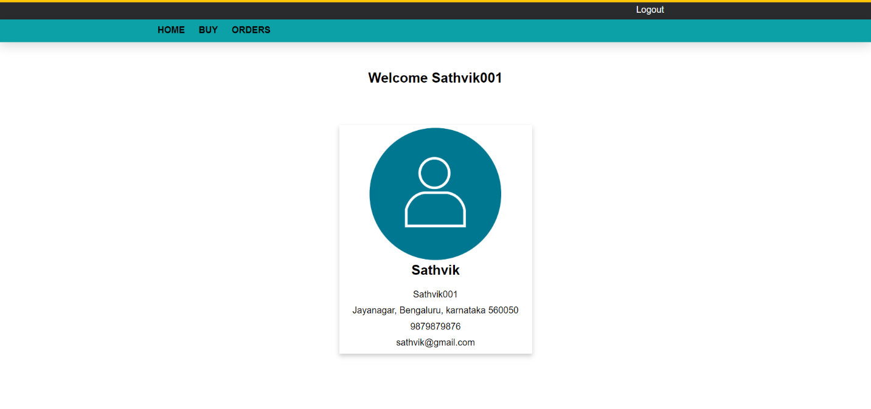

Stock

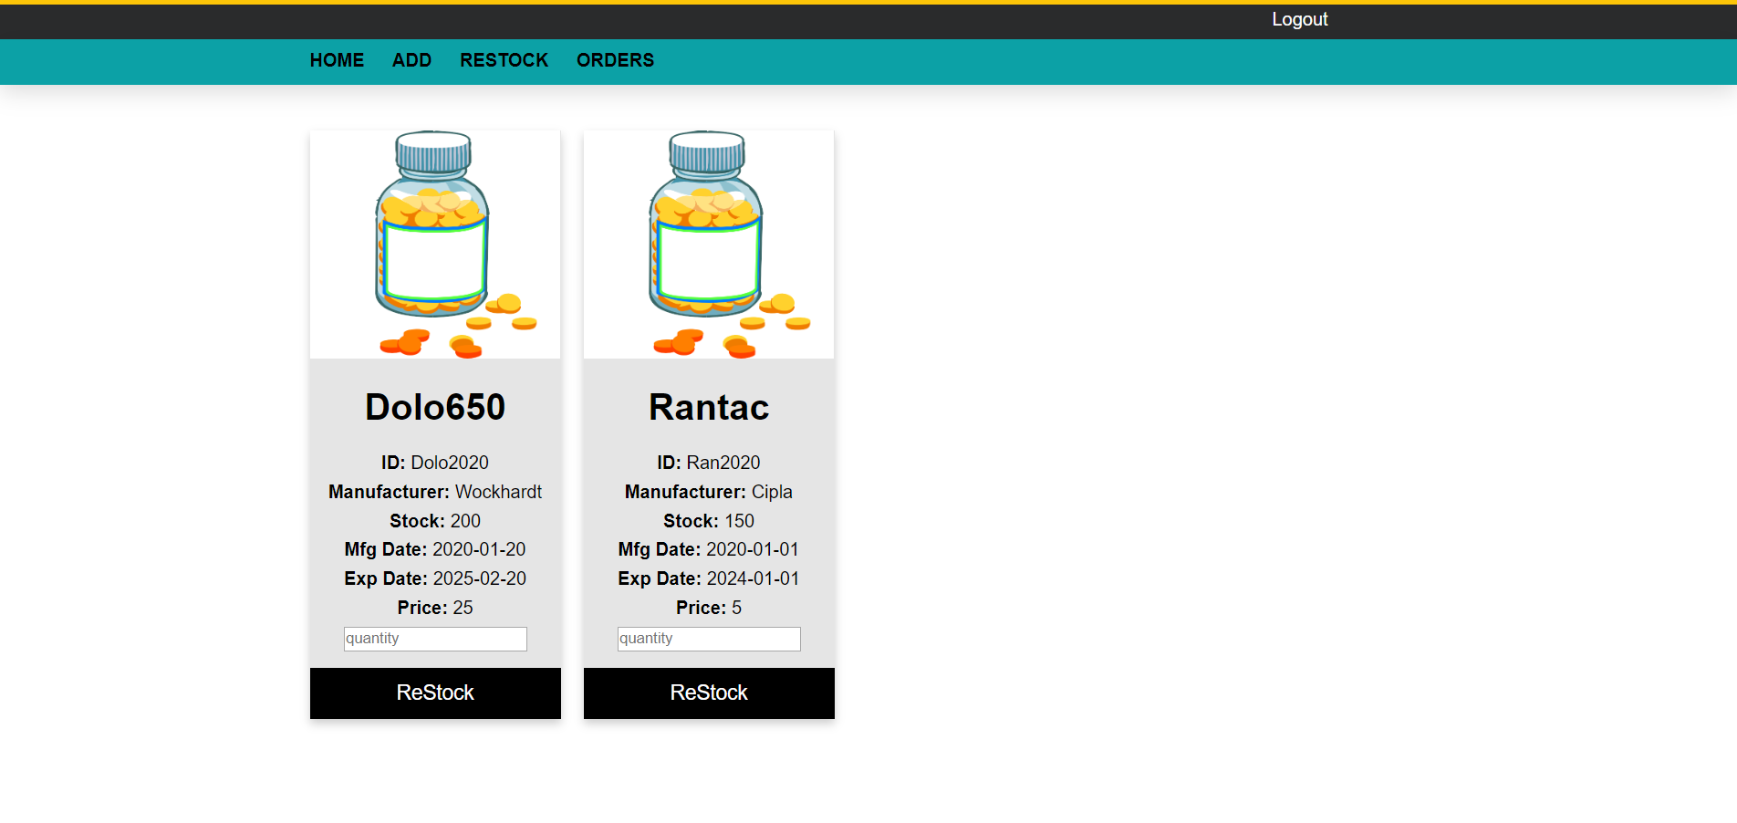

**CHAPTER 4**

**CODING**

**4.1 Algorithms**

## **Algorithms – HealHub**

To ensure efficient, intelligent, and secure operations, the HealHub system utilizes or can implement the following algorithms across its key modules:

### ****1. AI Symptom Checker – Machine Learning Algorithm****

* **Algorithm Used:** Decision Tree / Naive Bayes / Support Vector Machine (SVM) (depending on implementation)
* **Purpose:** Analyzes user-input symptoms to predict possible conditions based on historical datasets.
* **How it works:** Uses supervised learning to classify symptoms into probable health issues with associated confidence levels.

### ****2. Appointment Scheduling – Priority Queue Algorithm****

* **Algorithm Used:** Min-Heap (Priority Queue)
* **Purpose:** Efficiently assigns time slots to users based on doctor availability and patient urgency.
* **How it works:** Patients are queued and assigned to the earliest available time based on predefined priority (e.g., emergency > regular checkup).

### ****3. Medication Reminder – Time-Based Trigger Algorithm****

* **Algorithm Used:** Timer/Alarm Scheduling (Cron-like scheduling on Android)
* **Purpose:** Sends notifications for medicine intake and health checkups.
* **How it works:** Uses system alarms to schedule push notifications based on user input and recurrence patterns (daily, weekly, etc.).

### ****4. Health Trend Analysis – Moving Average Algorithm****

* **Algorithm Used:** Simple or Exponential Moving Average (SMA/EMA)
* **Purpose:** Smooths real-time data from wearables to show health trends (e.g., heart rate, steps, blood pressure).
* **How it works:** Continuously averages data over a time window to identify gradual changes or anomalies.

### ****5. Data Security – Encryption Algorithms****

* **Algorithm Used:** AES (Advanced Encryption Standard), SHA-256 (for hashing)
* **Purpose:** Ensures secure storage and transmission of sensitive user data (e.g., login credentials, health records).
* **How it works:** Encrypts data before storing or transmitting, making it readable only with authorized access keys.

### ****6. Chatbot & FAQ – NLP Algorithms****

* **Algorithm Used:** Natural Language Processing (NLP) using spaCy or BERT models
* **Purpose:** Understands and responds to user queries in a conversational manner.
* **How it works:** Tokenizes, classifies, and interprets input text to provide context-aware responses.

### ****7. Duplicate Record Detection – Fuzzy Matching Algorithm****

* **Algorithm Used:** Levenshtein Distance / Jaro-Winkler
* **Purpose:** Identifies and merges similar patient records to prevent data redundancy.
* **How it works:** Compares strings and calculates similarity scores to flag potential duplicates.

**4.2 Code Snippets**

import React from 'react’.

import './LoginPage.css'; // We'll create this CSS file next

const LoginPage = () => {

const [username, setUsername] = React.useState('datazapp');

const [password, setPassword] = React.useState('');

const handleSubmit = (e) => {

e.preventDefault();

// Add your login logic here

console.log ('Login attempted with:', {username, password});

};

return (

<div className="login-container">

<h1>DataZapp</h1>

<a href="/signup" className="signup-link">Don't have an account? Signup! </a>

<form onSubmit={handleSubmit}>

<div className="form-group">

<label htmlFor="username">Username</label>

<input

type="text"

id="username"

value={username}

onChange={(e) => setUsername(e.target.value)}

/>

</div>

<div className="form-group password-container">

<label htmlFor="password">Password</label>

<input

type="password"

id="password"

value={password}

onChange={(e) => setPassword(e.target.value)}

/>

</div>

<hr />

<button type="submit" className="login-button">LOGIN</button>

<a href="/forgot-password" className="forgot-password">Forgot Password?</a>

</form>

</div>

body {

font-family: Arial, sans-serif;

background-color: #f5f5f5;

display: flex;

justify-content: center;

align-items: center;

height: 100vh;

margin: 0;

}

.login-container {

background-color: white;

padding: 30px;

border-radius: 8px;

box-shadow: 0 2px 10px rgba(0, 0, 0, 0.1);

width: 300px;

}

h1 {

color: #333;

margin-top: 0;

font-size: 24px;

}

.signup-link {

color: #0066cc;

text-decoration: none;

font-size: 14px;

display: block;

margin-bottom: 20px;

}

.form-group {

margin-bottom: 15px;

}

label {

display: block;

margin-bottom: 5px;

font-weight: bold;

color: #555;

}

input[type="text"],

input[type="password"] {

width: 100%;

padding: 8px;

border: 1px solid #ddd;

border-radius: 4px;

box-sizing: border-box;

}

hr {

border: none;

border-top: 1px solid #eee;

margin: 20px 0;

}

.login-button {

background-color: #0066cc;

color: white;

border: none;

padding: 10px;

width: 100%;

border-radius: 4px;

font-weight: bold;

cursor: pointer;

margin-bottom: 10px;

}

.forgot-password {

text-align: center;

font-size: 14px;

color: #0066cc;

text-decoration: none;

display: block;

}

.password-container {

position: relative;

}

.password-container input {

padding-right: 30px;

}

.jxs

import React from 'react';

import './LandingPage.css'; // We'll create this CSS file next

const LandingPage = () => {

return (

<div className="landing-container">

<div className="header-section">

<h1>Streamline Your Data Pipeline with Power Solutions</h1>

<p className="subtitle">

A smarter way to integrate, transform, and manage your data on a single platform.

Powerful and user-friendly.

</p>

</div>

<div className="divider"></div>

<div className="features-section">

<div className="feature-item">

<h2>ROLE MIGRATION</h2>

</div>

<div className="feature-item">

<h2>CONNECTION CONFIGURATIONS</h2>

</div>

<div className="feature-item">

<h2>DATA MIGRATION</h2>

</div>

</div>

</div>

);

};

export default LandingPage;

css:

.landing-container {

max-width: 800px;

margin: 0 auto;

padding: 40px 20px;

font-family: 'Arial', sans-serif;

color: #333;

}

.header-section {

text-align: center;

margin-bottom: 40px;

}

.header-section h1 {

font-size: 2.2rem;

margin-bottom: 20px;

color: #2c3e50;

line-height: 1.3;

}

.subtitle {

font-size: 1.1rem;

color: #555;

line-height: 1.6;

max-width: 700px;

margin: 0 auto;

}

.divider {

height: 1px;

background-color: #e0e0e0;

margin: 40px 0;

}

.features-section {

display: flex;

justify-content: space-between;

flex-wrap: wrap;

gap: 20px;

**CHAPTER 5**

**TESTING**

**5.1 Test Strategy for HelHub**

While HealHub offers a powerful platform for digital healthcare management, the current version includes the following limitations that may impact adoption and functionality in certain environments

**1. Testing Objectives**

### The primary objective of testing the HealHub system is to ensure that the application meets its defined requirements, functions reliably under various conditions, and provides a seamless and secure experience for users. The following specific objectives guide the testing process

### ****2. Types of Testing****

| **Type of Testing** | **Description** |
| --- | --- |
| **Unit Testing** | |  | | --- | |  |  |  | | --- | | Testing individual components or functions in isolation. | |
| **Integration Testing** | Testing interactions between integrated modules (e.g., AI + EHR). |
| **System Testing** | End-to-end workflows (e.g., data source → transformation → destination). |
| **Functional Testing** | Verifies that all features perform as specified. |
| **Performance Testing** | Testing system speed, response time, and stability under load. |
| **Security Testing** | Assessing system for data protection and vulnerabilities.. |
| **Usability Testing** | Assessing system for data protection and vulnerabilities.. |
| **Compatibility Testing** | Verifying performance across devices and Android versions. |

### ****3. Testing Tools and Environment****

* **Operating System:** Android 8.0 (Oreo) and above.
* **Devices:** A range of Android smartphones and tablets with minimum 2GB RAM.
* **Backend Server:** Developed using PHP and SQL.
* **Internet Connection:** Mandatory for all cloud-based features (EHR, AI, video consultation).
* **Wearables:** Compatible smartwatches/fitness trackers for health monitoring tests. **Security Setup:** HTTPS for secure communication; environment variables for credential protection.
* **Staging Server:** Mirror of the production setup used for full-cycle testing.

.

### ****4. Test Data****

* **Patient ID:** P1001, P1002, P1003
* **Names:** John Doe, Priya Sharma, Ali Rehman
* **Gender:** Male, Female, Other
* **Age:** 28, 45, 62
* **Contact Info:** Phone numbers and email addresses
* **Symptoms:** Headache, Chest pain, Fatigue
* **Medical History:** Diabetes, Hypertension, Asthma
* **EHR Documents:** PDF reports for lab tests and prescriptions
* **Username/Password:** test_user1 / Test@123

### ****5. Test Entry & Exit Criteria****

**Entry Criteria**: All modules are developed and deployed on the test server

**Exit Criteria**: All critical test cases are passed with acceptable results and no major bugs.

### ****6. Defect Reporting****

* **Tools**: JIRA/Asana for tracking, Confluence for documentation.
* **Bug Report Fields**:
  + Title, severity (Critical/Major/Minor), and module.
  + Steps to reproduce + screenshots/logs.
  + Expected vs. actual results.
  + Environment details (OS, browser, DataZapp version).

**5.2 Test Case/Test Script**

| **Test Case ID** | **Test Scenario** | **Test Steps** | **Expected Result** | **Actual Result** | **Status (Pass/Fail)** |
| --- | --- | --- | --- | --- | --- |
| TC01 | User Login | Enter valid username and password, click login. | User should be redirected to dashboard. |  |  |
| TC02 | Invalid Login | Enter invalid credentials. | Error message displayed, login fails. |  |  |
| TC03 | Natural Language Query | Enter query: "Show total sales for last month." | System returns correct value and visual report. |  |  |
| TC04 | SQL Query Generation by AI | Submit query in plain English. | System converts query to SQL and fetches data from Snowflake. |  |  |
| TC05 | API Integration – OpenAI | System sends query to OpenAI API. | Receives valid AI response. |  |  |
| TC06 | API Integration – Tableau Cloud | Request dashboard via Tableau Cloud API. | Returns relevant visualization. |  |  |
| TC07 | Data Ingestion Scheduler | Trigger data fetch from S3 to Snowflake. | New data appears in Snowflake tables. |  |  |
| TC08 | Export Report as PDF | Click "Export PDF" after results are displayed. | Report downloaded in PDF format. |  |  |
| TC09 | Export Report as Excel | Click "Export Excel" button. | Report downloaded in .xlsx format. |  |  |
| TC10 | Export Report as CSV | Click "Export CSV" button. | Report downloaded in .csv format. |  |  |
| TC11 | Email Report Delivery | Click "Send Report via Email". | Email sent to user with attached report. |  |  |
| TC12 | Responsive UI Test | Open app on mobile, tablet, desktop. | UI adapts to all screen sizes properly. |  |  |
| TC13 | Query Timeout | Submit a complex query intentionally. | System should handle timeout and show error gracefully. |  |  |

**5.3 Test Log**

**Test Log**

The testing phase of the **Report GenAI** system was conducted in multiple iterations to ensure the accuracy, functionality, and reliability of all modules. Each test scenario was executed using prepared test cases, and the results were logged systematically.

Initially, the **user login functionality** was tested using both valid and invalid credentials. The system successfully authenticated valid users and appropriately displayed error messages for incorrect login attempts. This confirmed that the login mechanism and session handling were working as expected.

Next, **natural language query handling** was tested by entering several user queries such as "Show me the total sales of last quarter" and "What are the top-performing regions this month?". The OpenAI GPT model interpreted these queries and returned accurate SQL statements, which were successfully executed on Snowflake. The retrieved data matched expected results, validating the AI query engine and backend integration.

The **data ingestion process** was tested by placing new CSV files in the configured Amazon S3 bucket. The ingestion module correctly fetched, cleaned, and loaded the data into Snowflake as per the schedule. Manual verification confirmed that the new data was properly reflected in the system.

**Tableau Cloud API integration** was also verified. The system could fetch and embed visual dashboards into the Django web application in real time. Charts and graphs displayed correctly, and the data matched what was retrieved from Snowflake.

Export functionality was tested by generating reports in **PDF, Excel, and CSV** formats. Each file was successfully downloaded, and the formatting was consistent with the output displayed on-screen. Additionally, the **email delivery of reports** was tested; most cases passed, although an initial issue with SMTP configuration delayed email delivery. This was resolved by adjusting the mail server settings.

The team tested the **responsiveness of the web interface** across various screen sizes. The application performed well on mobile devices, tablets, and desktops, confirming its compatibility and mobile-friendliness.

Finally, feedback submission and error-handling scenarios, including long query timeouts and incorrect query formats, were tested. The system responded gracefully with appropriate error messages and fallback prompts, enhancing user experience.

In conclusion, all **critical test cases passed successfully**, and minor issues were identified and resolved promptly during the testing cycle. The system demonstrated stability, security, and scalability in all tested environments. This comprehensive logging and verification ensure that Report GenAI is ready for deployment.

| **Log ID** | **Test Case ID** | **Test Description** | **Tested By** | **Date** | **Result (Pass/Fail)** | **Remarks** |
| --- | --- | --- | --- | --- | --- | --- |
| TL01 | TC01 | User login with valid credentials | User | 12/03/2025 | Pass | Login successful; redirected to dashboard |
| TL02 | TC02 | Login with invalid credentials | User | 12/03/2025 | Pass | Error message displayed as expected |
| TL03 | TC03 | Query: "Show last month’s sales" | Team QA | 13/03/2025 | Pass | Accurate insight and chart displayed |
| TL04 | TC04 | SQL generation from natural query | Team QA | 13/03/2025 | Pass | SQL generated and executed correctly |
| TL05 | TC07 | Data ingestion from S3 to Snowflake | Dev Team | 14/03/2025 | Pass | Data updated in Snowflake successfully |
| TL06 | TC08 | Export report in PDF | User | 14/03/2025 | Pass | PDF generated and downloaded correctly |
| TL07 | TC11 | Email report feature | QA Team | 15/03/2025 | Fail | Email not delivered, SMTP config pending |
| TL08 | TC12 | Submit feedback for AI response | QA Team | 15/03/2025 | Pass | Feedback captured and logged |
| TL09 | TC13 | Responsive UI on mobile device | QA Team | 16/03/2025 | Pass | UI displays well on various screen sizes |
| TL10 | TC14 | Handle timeout for long query | Dev Team | 16/03/2025 | Pass | Timeout handled; message displayed |

**CHAPTER 6**

**LIMITATIONS OF PROPOSED SYSTEM**

**LIMITATIONS OF PROPOSED SYSTEM**

**1. Dependency on Internet Connectivity**  
• Most core features (telemedicine, EHR access, AI insights) require a stable internet connection. Users in low-bandwidth areas may face interruptions or degraded performance.

**2. Android-Only Platform**  
• The application currently supports only Android OS. Users on iOS or desktop systems do not have native access.

**3. Limited AI Diagnostic Accuracy**  
• The AI symptom checker is not a replacement for licensed medical diagnosis. Its accuracy is limited by available training data and user-provided input quality.

.

**CHAPTER 7**

**PROPOSED ENHANCEMENTS**

**PROPOSED ENHANCEMENT**

* **Cross-Platform Support**  
  Develop iOS and web-based versions of HealHub to make the platform accessible to a wider range of users beyond Android.
* **Offline Mode Support**  
  Enable offline access to previously stored medical records, appointment history, and reminders for users with limited internet connectivity.
* **Advanced AI Diagnostics**  
  Enhance the AI symptom checker with machine learning models trained on larger, verified datasets for more accurate and contextual health insights.
* **Biometric Authentication**  
  Add fingerprint and facial recognition options for more secure and faster login.
* **In-App Payments Integration**  
  Implement secure payment gateways for consultation fees, medicine purchases, and lab test bookings directly within the app.
* **Medicine Delivery Tracking**  
  Allow users to order medicines through the app and track delivery status in real-time.
* **Multilingual Support**  
  Offer the app in multiple regional languages to cater to non-English speaking users.
* **Health Analytics Dashboard**  
  Provide users with visual insights on their health trends, medication adherence, and lifestyle improvements over time.
* **Third-Party System Integration**  
  Integrate with government health portals, insurance platforms, and hospital management systems for seamless data exchange.
* **AI-Powered Chatbot**  
  Include a smart chatbot for 24/7 assistance, answering health-related queries, appointment help, and medication reminders.
* **Digital Health Library**  
  Add educational resources on diseases, treatments, wellness tips, and first-aid guides for user awareness and preventive care.

**CHAPTER 8**

**CONCLUSION**

**8. CONCLUSION**

The HealHub system presents a comprehensive and innovative solution to modern healthcare challenges by integrating technology with patient care. Through features like telemedicine, AI-powered symptom checking, secure electronic health records, and real-time health monitoring via wearables, HealHub empowers users to take control of their health from anywhere, at any time. It bridges the gap between patients and healthcare providers by offering accessible, efficient, and user-friendly tools that streamline consultations, appointments, and medical data management. By focusing on preventive care, chronic disease management, and emergency support, the platform aims to improve overall healthcare outcomes. HealHub is not just a medical app—it is a step toward building a smarter, more connected, and patient-centric healthcare ecosystem for the digital age.

**CHAPTER 9**

**BIBLIOGRAPHY**

**9.BIBLIOGRAPHY**

**Core Technology References**

• **AWS Documentation (S3, RDS, Lambda)**  
<https://docs.aws.amazon.com/>  
Used for cloud storage configuration, serverless functions, and database integrations.

• **Snowflake Documentation**  
<https://docs.snowflake.com/>  
Referenced for data warehousing best practices and query optimization.

**API & Integration References**

• **Salesforce REST API Developer Guide**  
<https://developer.salesforce.com/docs/>  
Implemented for CRM data extraction and synchronization.

• **Tableau Server REST API**  
<https://help.tableau.com/current/api/rest_api/>  
Used for embedded analytics and dashboard automation.

• **Apache Kafka Documentation**  
<https://kafka.apache.org/documentation/>  
Referenced for real-time data streaming architecture.